Local Place Plan Template

Purpose of Template
This template has been prepared to help community bodies create their own local place plans (LPPs). It is in the Microsoft Word format to allow community bodies to use elements (such as headings and tables) for their LPPs.

Front Cover, Design and Layout
The front cover plays an important role, attracting local residents, elected representatives, local businesses and potential project partners and funders to read your local place plan. It should include the following as a minimum:
- The title of your LPP (for example, Slamannan or Camelon Local Place Plan); and
- The time period that your LPP will cover (for example 2025 to 2030).
You might want to include the logo or name of your group that prepared the LPP or the coat of arms of your community, if you have one. Adding pictures to the front cover can make the area and focus of the LPP more recognisable to your audience. Actual examples of LPP front covers are shown below for illustration.
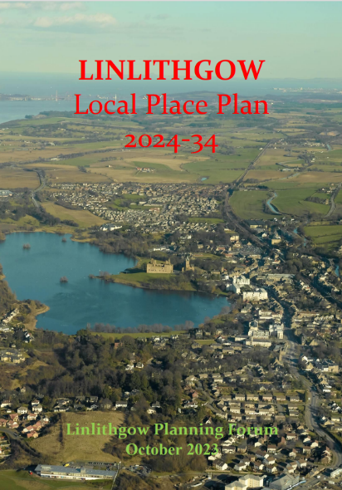
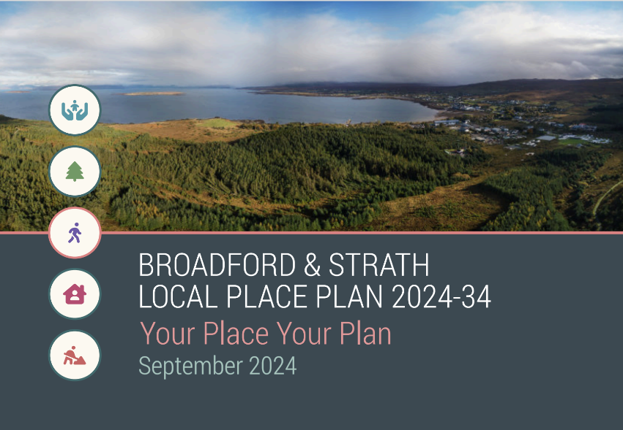

The design and layout of the whole document should be simple, and accessible to everyone including people with a disability. Writing in plain English can help your community and other stakeholders understand and engage with the priorities and proposals of the LPP.
As the saying goes, “a picture is worth a thousand words”. Maps, graphs, charts, diagrams, photographs and so on can communicate information more effectively than text. However, any image should be used in accordance with copyright law, which may include obtaining permission or licences for their use.
Useful weblinks:
SCOPE’s guidance on content accessibility
Plain English Guides
Falkirk Council Image Library

Contents Page
A contents page is useful to help your stakeholders navigate your LPP. This page is optional and may not be necessary for short LPPs that are a few pages long.

Introducing Our Local Place Plan
This section should introduce who you are and why you have prepared the plan. You could use sub-headings such as ‘About Us’ and ‘Purpose of Local Place Plan’ to help structure the introduction section.
The local place plan must include a detailed map, clearly showing the boundaries of the area of the LPP. The introduction is a logical place for the map, helping your stakeholders identify the area of your LPP at the beginning of the document. The boundaries of the map are for you to define but they could extend, for example, to a whole town, a neighbourhood within a town, a village, or group of villages. They could also be limited to just a large park or site within the community. You can create your own maps for free using the Council’s Open Data Hub. Alternatively, Community Councils can use Parish Online to map the boundaries and what is important to them. They can get 12 months of free access to the tool by going to Parish Online and using the code cms12 when signing up.

Our Place – Description and Context
It would be good to describe your community, and what it is currently like to live, work, relax, do business and move around in your place. You could use the following headings to structure this information:
- Environment (for example, biodiversity, local landscape, vacant and derelict land, historic environment and so on)
- Community and Economy (such as the population and employment profile of the community, housing, level of deprivation and so on)
- Local Facilities and Services (such as community halls and libraries, play parks and open spaces, healthcare, schools and shops)
- Transport (such as accessibility and connectivity within, to and from your place by active travel, public transport and car)
You can, if you wish, use your own headings to structure the context to your local place plan.
You can use the Council’s place profile for your community to gather the facts and figure, and set the scene, for the LPP. A place profile is freely available online for each of the settlement areas:
- Falkirk
- Bo’ness
- Bonnybridge and Banknock
- Braes and Rural South
- Denny
- Grangemouth
- Larbert and Stenhousemuir
- Rural North
In the context section, you may want to refer plans and programmes of agencies such as the Council. It is worth mentioning the development plan which in Falkirk comprises Scotland’s National Planning Framework 4 and the Falkirk Local Development Plan 2. Local place plans are required to have regard to the development plan and it provides the over-arching framework for guiding decisions on the use and development of land in your community.
In your LPP, you can recognise land or buildings that is particularly important to your community. The location of such land or buildings will need to be shown on a map which could go here or in the introduction section. You might want to include locally important land or buildings, for example, to support tourism, heritage or outdoor access or improve and make better use of local assets such as community buildings and spaces (like allotments, woodlands and parks).

Community Engagement and Feedback
Engagement is really important as this will help gain a good understanding of the challenges, views and aspirations of the people who live, visit and work in your community. This section should outline the key engagement activities that your group has carried out and the summary and analysis of the feedback you have received.
You can engage with the community in several ways but remember to try and engage as many members of the community and key stakeholders as possible. This is important to ensure the plan accurately reflects aspirations and needs of the community, and key stakeholders, including those with the least heard voices. Our brief guide provides links to further guidance and tools, such as the Place Standard, that could help you structure your engagement with the community and key stakeholders on the future use and development of land.

Community Vision Statement and Objectives
A vision statement sets out what you want your community to be like in the future. It should reflect the community’s agreed aspirations and align closely to the use and development of land. Objectives should expand on the vision statement by providing further detail on the agreed aspirations.
You should consider the following questions to inform your vision statement and objectives in the LPP:
- What do you as a community want to achieve and by when?
- What does the community want to retain?
- What do you want to improve?
- What difference will this make?
Concise themes are a good way to group and link your objectives and proposals to the community vision statement. You can use your own themes or draw inspiration from other plans such as National Planning Framework 4 and Falkirk Local Development Plan 2.

Action Plan and Proposal Maps
The LPP must include a statement of your proposals as to the development or use of land within the LPP area. This statement can take the form of an Action Plan, identifying and listing proposals along with actions, timescales and the delivery lead(s). Proposals must be realistic, taking into account wider policies, available resources and factors such as land ownership. Merely putting something in a LPP will not make it happen.
Proposals should relate to the vision statement and objectives identified to ensure close alignment with the community’s agreed aspirations for the area. Themes can help with this.
It would be useful to prioritise proposals in the Action Plan as short, medium and long term projects with indicative timescales. Reintroducing a community event like a gala day could be a short-term action whereas a long-term action could be the community ownership and redevelopment of a derelict site. A template action plan is provided below along with a completed example of a proposal to illustrate.
Table 1: Template action plan
Proposal | Theme(s) | Actions | Timescale | Priority | Delivery Lead
Develop an outdoor gym and community growing area in our local park | Health and Wellbeing | - Set up a friends of park group to have a greater say on how the park could be improved  -Develop a park masterplan  - Engage with Falkirk Council and other potential funders | Long term (2030+) | High | Community Body

If a proposal that relates to the development or use of a specific area of land or buildings, then a map must be provided in the LPP identifying the location of the land or buildings. Good examples of proposal maps are shown below. We strongly recommend the proposal maps reference proposals by number and include a legend briefly describing each proposal.
Proposal Map from the Ardgour Local Place Plan
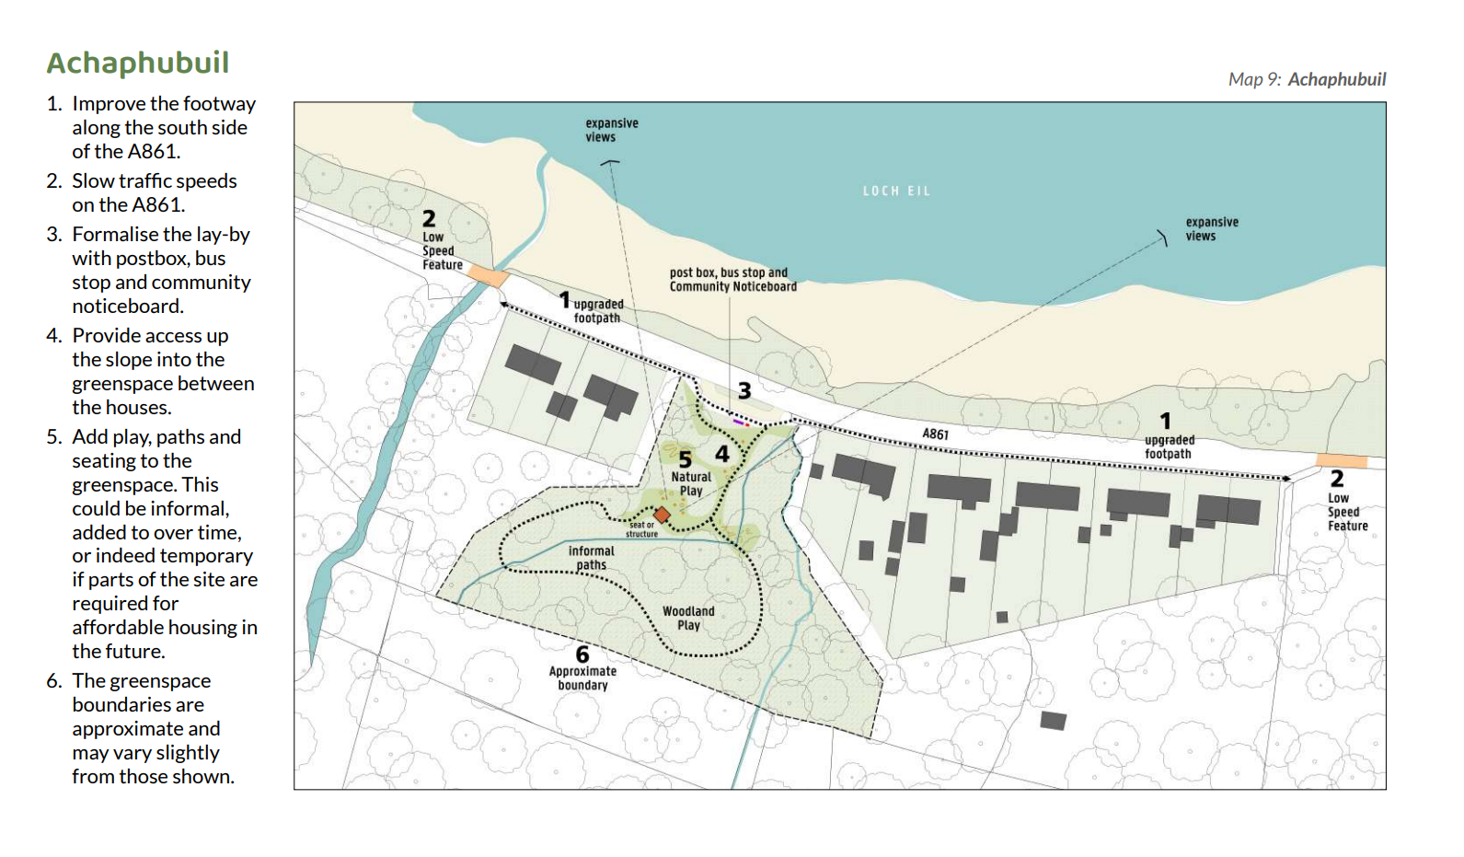
Proposal Map from the Benarty Local Place Plan
